**Classic BADI Implementation**

1. Go to tcode SE19. In the create implementation section, choose Classic BADI->give the name of the BADI created (For creation of BADI please refer Demo1_ClassicBADIDefinition)

Click on create.

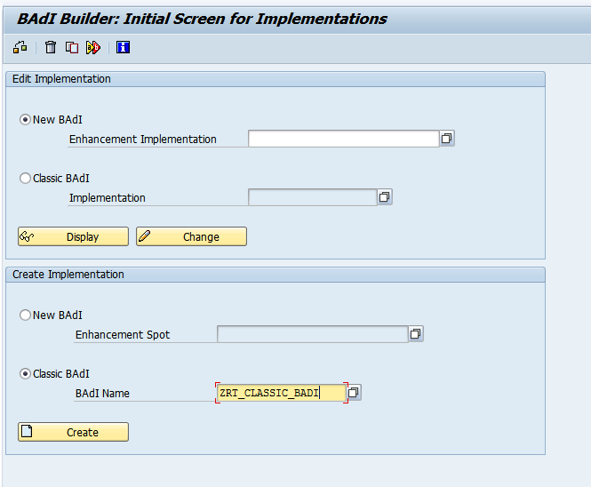

1. Give a suitable implementation name starting with Z/Y. Click on continue

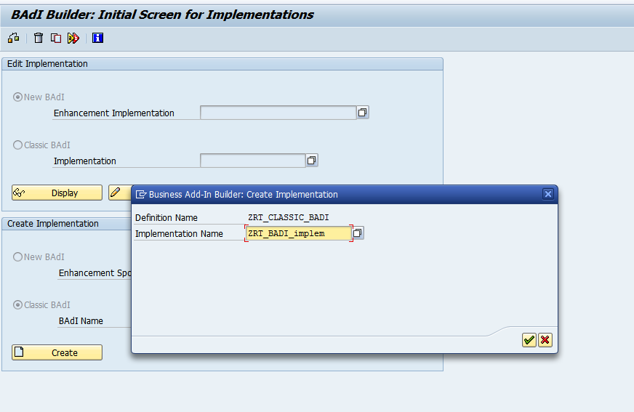

1. Give short description. Click on Interface tab

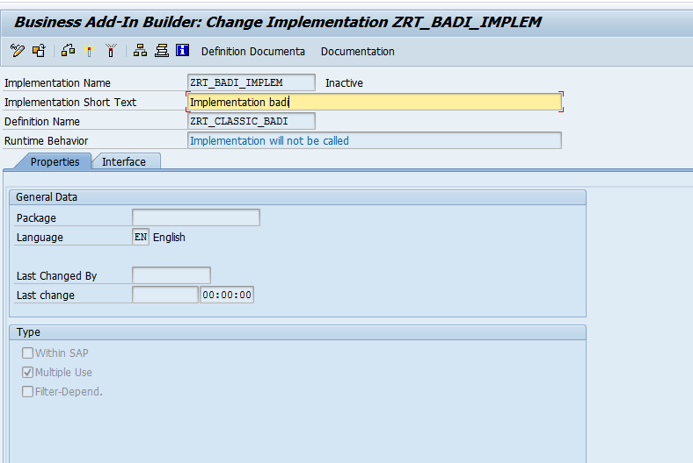

1. In the interface tab, double click on class and create it.

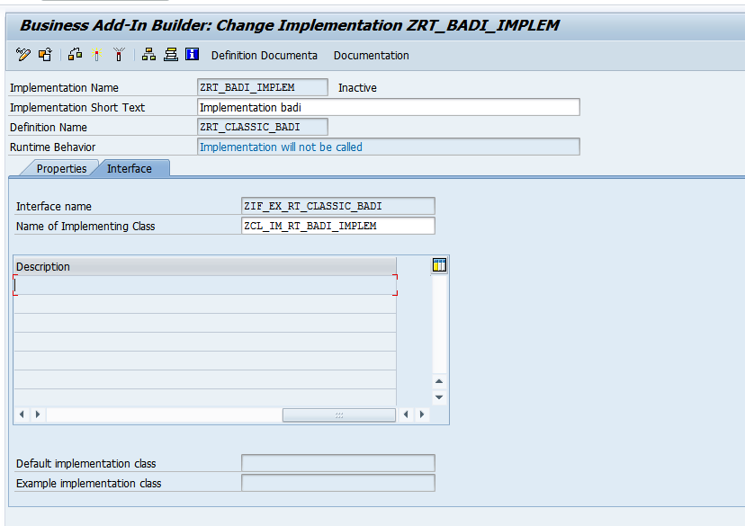

1. The class opens up. In the method METH_FLIGHT, add the below logic

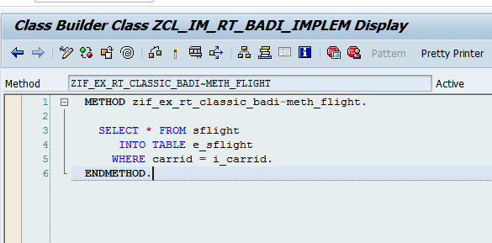

1. Save the class and go back

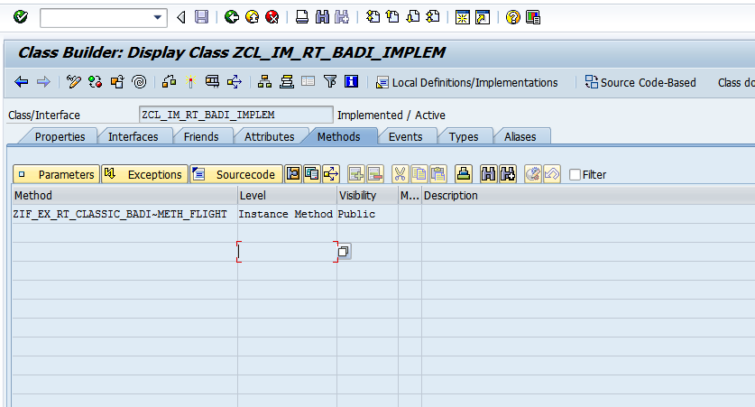

1. Save and activate the BADI Implemetation

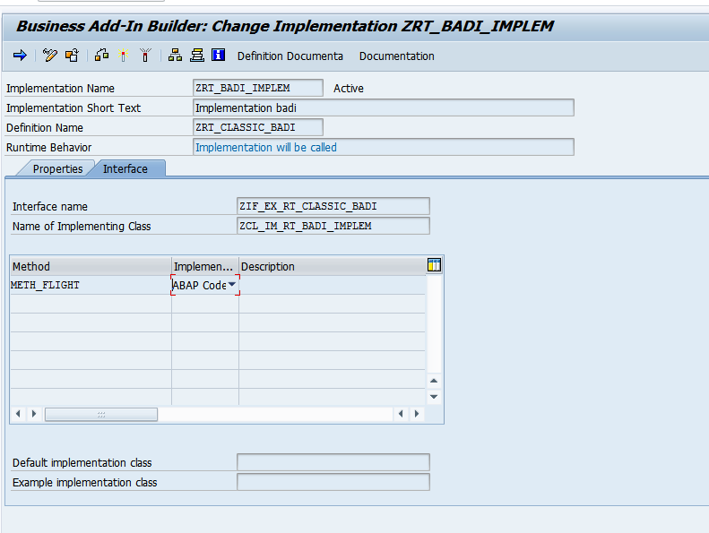

1. Create a Report in se38 and add the below logic

1. *&---------------------------------------------------------------------*  
   *& Report ZCLASSIC_BADI_PRG  
   *&---------------------------------------------------------------------*  
   *&  
   *&---------------------------------------------------------------------*  
   REPORT ZRT_CLASSIC_BADI_PRG.  
     
   DATA:  IT_TAB TYPE  ZBADI_SFLI,  
          WA_TAB LIKE LINE OF IT_TAB.  
     
     
   PARAMETERS P_carrid type S_CARR_ID.  
     
     
   START-OF-SELECTION.  
     
   DATA OBJ1 TYPE REF TO ZIF_EX_RT_CLASSIC_BADI."Interface from se19  
     
     
   CALL METHOD cl_exithandler=>get_instance  
     EXPORTING  
       exit_name                     = 'ZRT_CLASSIC_BADI'"Name of badi while creating BADI in se19  
   *    null_instance_accepted        = SEEX_FALSE  
   *  IMPORTING  
   *    act_imp_existing              =  
     CHANGING  
       instance                      = OBJ1  
   *  EXCEPTIONS  
   *    no_reference                  = 1  
   *    no_interface_reference        = 2  
   *    no_exit_interface             = 3  
   *    class_not_implement_interface = 4  
   *    single_exit_multiply_active   = 5  
   *    cast_error                    = 6  
   *    exit_not_existing             = 7  
   *    data_incons_in_exit_managem   = 8  
   *    others                        = 9  
           .  
   IF sy-subrc <> 0.  
   * Implement suitable error handling here  
   ENDIF.  
     
   CALL METHOD obj1->meth_flight  
     EXPORTING  
       i_carrid = P_carrid  
     CHANGING  
       e_sflight  = IT_TAB  
       .  
     
     
   LOOP AT IT_TAB INTO WA_TAB.  
     WRITE : / WA_TAB-carrid,  
               WA_TAB-connid.  
     
     
     
     ENDLOOP.

10) The expected output is as follows

